**Intern Project Report: Israeli-Palestinian Conflict Analysis and Predictive Modeling**

**Name :** Arumuga Tamil Selvan M

**Reg No :** 953622243010

**Project Title**: *Data-Driven Analysis and Predictive Modeling of the Israeli-Palestinian Conflict*

**Submitted by**: Arumuga Tamil Selvan  
**Affiliation**: B.Tech in Artificial Intelligence & Data Science, Ramco Institute of Technology  
**Project Team**: Israeli-Palestine Project Team  
**Submission Date**: January 8, 2024

**Project Overview**

The Israeli-Palestinian conflict remains one of the most intractable geopolitical challenges of the modern era, marked by decades of violence, political tension, and unresolved territorial disputes. Our project conducts an in-depth data-driven analysis, focusing on conflict-related fatalities within the context of the Israeli-Palestinian conflict.

The primary objective of this project is to leverage data analytics and machine learning techniques to uncover patterns in conflict-related fatalities and to build predictive models for forecasting future trends. We aim to provide valuable insights that contribute to the broader understanding of the conflict, foster informed discussions, and offer potential pathways for resolution based on data-driven predictions.

**Problem Statement**

The Israeli-Palestinian conflict has resulted in significant loss of life, with fatalities often acting as a grim indicator of the severity and escalation of violence. However, accurate predictions of future fatalities and conflict intensity are challenging due to the complex and multifaceted nature of the conflict. Existing solutions lack a comprehensive, data-driven approach to forecasting fatalities and understanding the underlying patterns that drive escalation. Our project seeks to bridge this gap by applying advanced data analysis, machine learning, and time series forecasting techniques to predict conflict-related fatalities with high accuracy.

**Methodology**

The project involves the following stages:

1. **Data Collection**:  
   Data on conflict-related fatalities was gathered from multiple sources, including historical records, news reports, and publicly available databases related to the Israeli-Palestinian conflict.
2. **Data Preprocessing**:  
   The data was cleaned and preprocessed to remove inconsistencies and ensure the dataset was ready for analysis. This step involved handling missing values, feature engineering, and transforming data into a format suitable for machine learning.
3. **Exploratory Data Analysis (EDA)**:  
   We used Python libraries such as **Matplotlib**, **Seaborn**, and **Plotly** to visualize the data and identify trends, patterns, and anomalies related to fatalities.
4. **Predictive Modeling**:  
   Several machine learning algorithms were used to build models that could predict future fatalities based on historical data:
   * **Random Forest**: Achieved an accuracy of 99.68%.
   * **K-Nearest Neighbors (KNN)**: Precision of 0.875.
   * **Logistic Regression**: Precision of 0.97.
   * **Support Vector Machine (SVM)**: Precision of 0.91.
   * **Decision Trees**: Achieved high accuracy of 99%.
   * **XGBoost**: Accuracy of 99%.
5. **Time Series Forecasting**:  
   To predict future fatalities, **Long Short-Term Memory (LSTM)** networks were employed. LSTM models are well-suited for time-series data and were used to forecast future conflict trends based on historical patterns.
6. **Dashboard Development**:  
   We created interactive dashboards using **Power BI**, allowing stakeholders to explore the data, visualizations, and predictions interactively. These dashboards provide a user-friendly interface for engaging with complex data.

**Results and Findings**

**Predictive Model Performance**

Below is a summary of the performance metrics for different machine learning models used in this project:

| **Model** | **Precision** | **Recall** | **Accuracy** | **F1-Score** |
| --- | --- | --- | --- | --- |
| Random Forest | 0.995 | 0.995 | 0.99 | 0.99 |
| K-Nearest Neighbors | 0.875 | 0.725 | 0.93 | 0.775 |
| Logistic Regression | 0.97 | 0.675 | 0.94 | 0.745 |
| Support Vector Machine | 0.91 | 1.00 | 0.98 | 0.95 |
| Decision Tree | 0.995 | 0.985 | 0.99 | 0.99 |
| XGBoost | 0.995 | 0.975 | 0.99 | 0.985 |

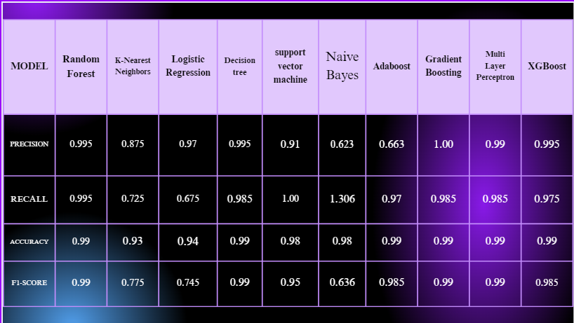

* **Random Forest** performed exceptionally well, with an accuracy of 99% and a precision of 0.995, making it one of the most reliable models for this dataset.
* **K-Nearest Neighbors** (KNN) had slightly lower performance with precision of 0.875, but was still effective in making predictions.
* **Logistic Regression** and **SVM** models performed fairly well, showing that simpler models can still yield good insights.
* **XGBoost** and **Decision Trees** performed with near-identical results, showing strong accuracy and precision.

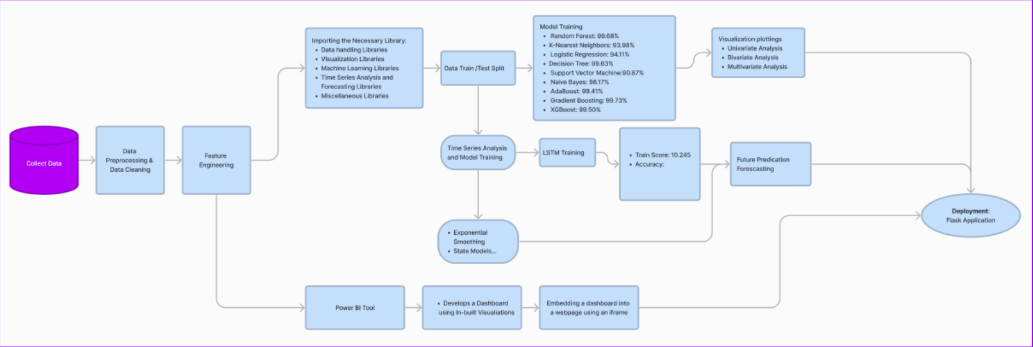

**Time Series Forecasting with LSTM**

LSTM models were used to predict future conflict trends, and the results showed promising accuracy in forecasting conflict-related fatalities. These predictions can be critical in understanding the escalation or de-escalation of the conflict, aiding policymakers and peacekeeping bodies in decision-making.

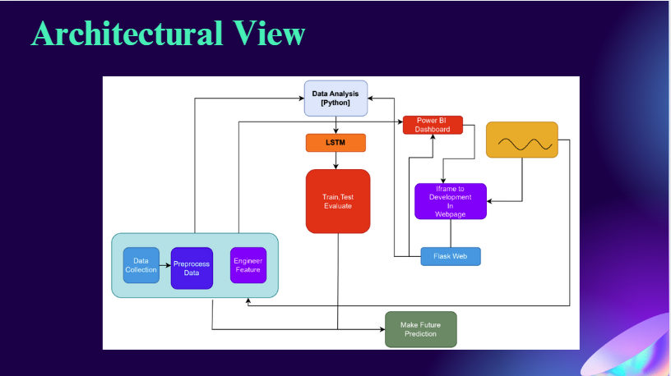

**Data Visualizations**

The project leveraged Python libraries such as **Matplotlib**, **Seaborn**, and **Plotly** to generate insightful visualizations. These visualizations helped to reveal the temporal patterns of fatalities, showing spikes in violence and trends over the years. They also provided a clearer view of the geographical distribution and contextual factors influencing the conflict.

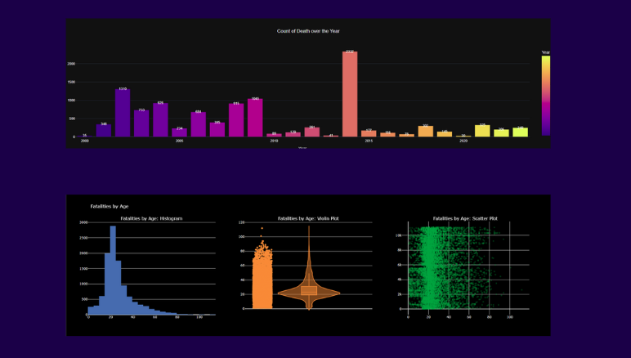

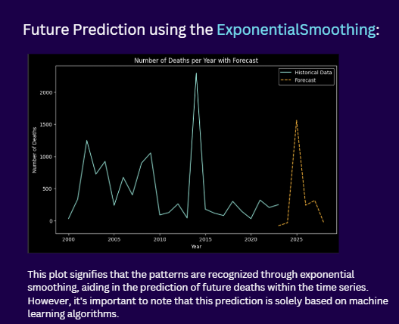

**Tools and Technologies Used**

* **Programming Language**: Python
* **Libraries**:
  + Data Visualization: **Matplotlib**, **Seaborn**, **Plotly**
  + Machine Learning: **Scikit-learn**, **XGBoost**, **TensorFlow (LSTM)**
  + Time Series Analysis: **Exponential Smoothing**, **State Space Models**
* **Data Handling**: **Pandas**, **NumPy**
* **Dashboard**: **Power BI**
* **Web Framework**: **Flask** (for deploying interactive applications)

**Challenges and Solutions**

**Challenges:**

* **Data Quality**: Inconsistent and sparse data was a challenge throughout the project. Handling missing data and ensuring accurate feature engineering was essential.
* **Model Overfitting**: Some models initially overfitted the training data, especially with small datasets. Techniques such as cross-validation were employed to address this issue.
* **Time Series Complexity**: Predicting fatalities based on historical data with changing geopolitical dynamics proved difficult. LSTM models offered a robust solution, but fine-tuning the parameters took considerable effort.

**Solutions:**

* Implementing data imputation and normalization techniques helped mitigate the impact of missing data.
* Using ensemble methods like **Random Forest** helped reduce overfitting.
* Advanced techniques like **LSTM** and **Exponential Smoothing** models were employed to address the time-series forecasting challenges effectively.

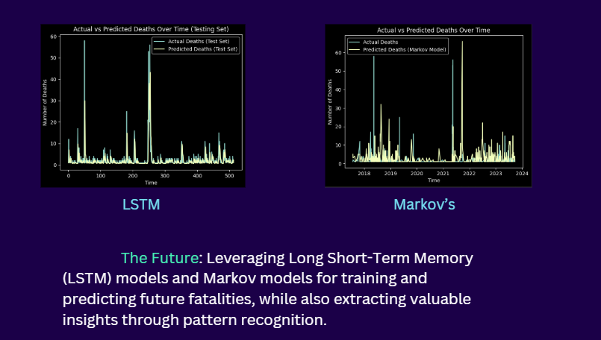

**Conclusion**

This project has successfully demonstrated the power of data science and machine learning in addressing complex geopolitical issues. By analyzing conflict-related fatalities and using predictive modeling techniques, we have uncovered valuable insights that can contribute to the ongoing discourse on the Israeli-Palestinian conflict. The use of **Random Forest**, **LSTM**, and other machine learning models has allowed us to predict future fatalities with high accuracy, providing a tool for policymakers to better understand the dynamics of conflict escalation and de-escalation.

The integration of **Power BI** for interactive dashboards enhances the accessibility of the data, enabling stakeholders to engage with and interpret the findings in an interactive manner.

This project not only contributes to the understanding of the Israeli-Palestinian conflict but also sets the groundwork for future research on conflict prediction and resolution.

**Links and Resources**

* **Work Flow Diagram**: [Figma Work Flow Diagram](https://www.figma.com/file/DZ2EQyv5r0MbtVY42r0XZz/Isreali-Palestine-Project?type=whiteboard&node-id=0%3A1&t=2cKIPLRmUtLPEAIo-1)
* **Source Code**:
  + [Colab Notebook](https://colab.research.google.com/drive/1JwSABY3BK40SYVUghsuJ63avB8Vd0bn2?usp=sharing)
  + [GitHub Repository](https://github.com/Arumuga-Tamil-Selvan/Isreal--Palestine-Conflicts.git)
* **PowerPoint Presentation**: [Canva Presentation](https://www.canva.com/design/DAFnUE00F5w/lsdWvQpOQo_zwnHY0u6hyQ/edit?utm_content=DAFnUE00F5w&utm_campaign=designshare&utm_medium=link2&utm_source=sharebutton)

**Acknowledgments**

I would like to express my sincere gratitude to my project supervisor and all team members for their continuous support and guidance throughout the project. Special thanks to the faculty at Ramco Institute of Technology for their mentorship and the resources provided.